Volume 7, Issue 2 June 2021

GHANA CONSULTING ENGINEERS ASSOCIATION NEWSLETTER

THE GCEA NEWS

Inside this issue:

|  |  |
| --- | --- |
| GCEA—Who we are | 1 |
| Knowing MFs—Services | 2 |
| Plus Consult Ltd. |  |
| Profile of Director of SPL | 3 |
| Objectives for 20/21 | 4 |
| Excerpts from FIDIC- | 5 |
| AFRICA Infrastructure |  |
| Conference 2021 |  |
| FIDIC CEO Update No. 17 | 6 |
| Upcoming Seminar | 9 |
| Crossword Puzzle No. 2 | 10 |
| New GCEA Members | **12** |

WHO WE ARE..

GCEA is the Ghana Consulting Engineers Association. It was incorporated on 21st February 1973 and charged with promot-ing and implementing the con-sulting engineering industries in Ghana on behalf of its Mem-ber firms and to disseminate information and resources of interest to its members.

**MEMBERSHIP**

Membership of the Association shall be open to firms and indi-viduals primarily engaged in engineering consultancy and

related activities whose head office or branch office is in Ghana and who subscribe to the objects of the Associa-tion.

**AFFILIATIONS**

GCEA is recognized by the Ghana Institution of Engi-neering as a formal Associa-tion of Consulting Engineers in Ghana and a key partner to the growth of the engi-neering profession. It is a member of FIDIC Africa; International Federation of Consulting Engineers

(FIDIC). Some aims and objectives of GCEA include;

* Formulating policies and guidelines upon which the practice of profes-sional engineering ser-vices shall be performed.
* Enhancing the collective reputation and economic viability of the members of the Association.
* Promoting education and training in engineering and its professional prac-tice.

THE GCEA NEWS



SERVICES PLUS CONSULT LIMITED was established in 1999 from its antecedent Services Plus Lim-ited which was revised in 2017. The location by through Ghana Post is GA 5979743

The firm comprises of a team of engineering consultants namely, Joseph Atuahene Omani and Eric Ac-quaah with Jonathan Yeboah Omani as the Administrative director.

Also the firm has in addition, a staff strength of 2No graduate engineers, 1No technologist and 4No. auto cad technicians and supervisors. There is a company secretary, a driver and a janitor.

The firm is a registered member of the Ghana Consulting Engineers Association (GCEA) and undertakes full range of Mechanical and Electrical Engineering services including economic and engineering feasibil-ity studies. The firm generally takes the form of preliminary planning and advising, designing, preparing drawings, specifications and contract documentations. Also the firm undertakes supervision of all mechani-cal and electrical services associated with buildings and other structures and infrastructure.

The main functions of the firm are; to act on behalf of the client in planning the most economical way of providing engineering services, i.e. preparing tender documents to enable competitive tenders to be ob-tained, tender evaluation, awarding of contracts, advise and making visits of inspection to ensure that the works are carried out in accordance with the specifications and to good engineering standards of workman-ship.

In addition to these functions, the firm also plays the role of technical advisors to clients on matters affect-ing the ordering and installation of equipment (mechanical and electrical) and also on matters affecting post installation problems e.g. malfunctioning of equipment and maintenance agreements. The firm also works on valuation of plant and machinery equipment.

Scope of services offered include;

1. **MECHANICAL ENGINEERING;** Hospital Mechanical Equipment Installation Designs, Air Condition-ing, Refrigeration & Ventilation, Water Supply and Distribution, Fire Protection, Drainage Works etc.
2. **ELECTRICAL ENGINEERING;** Power Distr ibution Networ ks up to 33KV, Power Systems Studies, Transformer and Generator Sub-stations, Rural Electrification, General lighting and Small Power, Computer Networking etc.
3. **MANAGEMENT SERVICES;** Technical & Economic feasibility studies, Preparation of contract documents and Bid evaluations, Project Management and Technical Assistance etc.

PAST PROJECTS HANDLED INCLUDE;

* Best Western Premier Hotel; 120 bedroom hotel facility at Airport West completed in 2010.
* Fiesta Royale; 100 bedroom 4-star hotel facility at Dzorwulu in Accra completed in 2008.
* Supervision of Head Office Building for National Health Insurance Authority in Accra.
* Data Centre for Vodafone Ghana at Gbawe in Accra.
* Supervision of Mechanical installations on the 100,000 tonne capacity warehouse complex at Apowa in Tako-radi.
* Mechanical Design and Supervision of Habour and Jetty facility construction including petroleum depot at De-bre in the Northern Region for BOST Petroleum Limited; among others.

Ing. Joseph A. Omani— *Direc-tor, Services Plus Consult Ltd.*

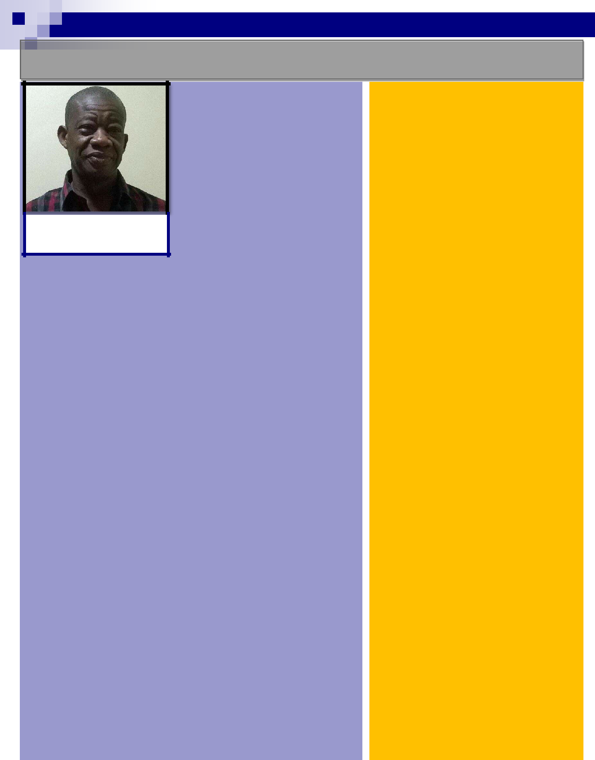THE GCEA NEWS

PROFILE OF DIRECTOR OF SERVICES PLUS CONSULT LTD.

Ing. Omani is a Mechanical Engi-neer with over thirty (30) years of vast Professional experience in several disciplines of Mechanical Engineering Installations in build-ing services. His vast experience

 covers Plumbing and Fire-Fighting

Installations, Industrial Kitchens, Laundry and Hospital equipment

installations, Air-Conditioning and Ventilation Installation, External soil and Wastewater Disposals and Sewer and Sewer-age Treatment works.

He also has vast experience in sources of potable water produc-tion and conversant with the design and distribution of potable water in the rural and urban areas in Ghana. He has undertaken a research activity in potable water extraction in Ghana, a pro-ject he undertook in a joint workshop programme with Ghana Water Company and National Service Secretariat in 1987 in Tamale. The programme includes production of hand pumps with locally made materials for wells/boreholes under the Community Improvement Unit (CIU).

He has experience in close-control precision type air-conditioning installations for data centres and IT rooms which includes humidity controls with fire suppression systems, etc.

He is also experienced in the knowledge covering Pre-contract and Post Contract Engineering Installations, Contract Manage-ment and Administration for Building Services.

He has teamed up with other profes-sionals in executing projects for the Ministries of Health, Education Youth and Sports, SSNIT, SIC Insurance, SIC Life, Department of Urban Roads, World Bank funded projects, VRA, The Church of Jesus Christ of LDS, The Church of Pentecost, offices buildings, residential buildings and various hotels projects such as Best Western Premiere and Marriott, etc. in Ghana.

Ing. Omani is also conversant with the Petroleum Industry having engaged in the design and supervision of the In-stallation of Bulk Petroleum Storage Tanks and the Expansion of the Ku-masi Depot for the BOST Petroleum Limited under Twum Boafo and Part-ners.

Page 3

THE GCEA NEWS

|  |  |  |  |  |  |  |
| --- | --- | --- | --- | --- | --- | --- |
|  |  |  |  |  |  |  |
|  |  |  |  |  |  |  |
|  |  |  |  |  |  |  |
|  |  |  |  |  |  |  |
|  |  |  | **NO.** | **2020/ 21 OBJECTIVES** |  |  |
|  |  | |  |  |  |  |
|  |  | | 1. | Review and improve the administration operations to facilitate the achievement |  |  |
|  |  |  |  | of our vision. |  |  |
|  |  | |  |  |  |  |
|  | 2. | Promote policies that serves the interest of GCEA at both Governmental/ |  |  |
|  |  |  |  | Institutional Level to make the Association attractive to consulting firms e.g. |  |  |
|  |  |  |  | Professional Fees |  |  |
|  |  |  |  | Tax considerations |  |  |
|  |  |  |  | Local Content considerations |  |  |
|  |  |  |  | Public Procurement Authority (PPA) considerations |  |  |
|  |  |  |  | Collaboration with Metropolitan, Municipal and District Assemblies (MMDA) |  |  |
|  |  |  |  | Collaboration with Association of Contractors/BEP’s |  |  |
|  |  |  |  | Collaboration with sector Ministries/Organizations |  |  |
|  |  | |  |  |  |  |
|  |  |  | 3. | Support and enhance the operations of the committees to make them effective. |  |  |
|  |  | |  |  |  |  |
|  | 4. | Encourage more interactions with Council Members and Member Firms on the |  |  |
|  |  |  |  | Vision and benefits of the Association. |  |  |
|  |  | |  |  |  |  |
|  |  |  | 5. | Bringing in other Consulting Firms in the Built Environment (eg. Quantity Sur- |  |  |
|  |  |  |  | veyors and Architects) into our fold. |  |  |
|  |  | |  |  |  |  |
|  | 6. | Training in Management of Engineering Consultancy through seminars, work- |  |  |
|  |  |  |  | shops and webinars (especially in these COVID-Times). |  |  |
|  |  | |  |  |  |  |
|  |  |  | 7. | Build a strong Relationship with FIDIC. |  |  |
|  |  | |  |  |  |  |
|  |  | | 8. | Build a strong Relationship with FIDIC Africa. |  |  |
|  |  | |  |  |  |  |
|  |  |  | 9. | Build a strong Relationship with Sector Ministries (GHA/MRH,MWH, MoA, |  |  |
|  |  |  |  | MoR, MoF etc). |  |  |
|  |  |  |  |  |  |  |

Page 4

THE GCEA NEWS

EXCERPTS FROM THE FIDIC AFRICA 2021 INFRASTRUCTURE CONFERENCE (VIRTUAL)



**FIDIC-AFRICA PRESIDENTS’ MEETING**

The meeting was held on the 4th of May 2021 to discuss FIDIC’s proposed Regionalisation Strategy and the benefits to our African Member Associa-tions.

It was attended by Presidents of Member Associations.

GCEA was represented by the President, Ing W.D. Albert Viala.

**Interesting points raised;**

* + FIDIC Africa would remain as a regional group with their own Executive Committee.
  + Potential to support the wellbeing of MAs through shared Secretariat ser-vices
  + Acceleration of the capacity building processes with more African ac-credited trainers, arbitrators and adjudicators.
* FIDIC financial support would assist the Secretariat to Market FIDIC Africa more broadly across the continent, including the Francophone countries.

—————————————————————–——————————————————————————

**FIDIC-AFRICA 2021 INFRASTRUCTURE CONFERENCE**

The 27th Annual FIDIC Africa virtual Conference was held on the 18th and 19th May 2021.

The theme of the conference was **“The Role of the Consulting Engineer in a Changing World; the African Per-spective.”**

***Issues discussed were;***

* Ethical Dilemmas in Project Implementation
* Challenges and Disruptions
* Engineering Consultant’s Experience
* Project Procurement & Delivery
* Agenda of Infrastructure & Social Development
* Role of the Consulting Engineer

**The Directors, Presidents and Secretaries Meeting was held on the 17th of May 2021.**

* 15 Member Associations attended the meeting.
* The meeting was held to identify common issues pertaining to procurement, Training, etc.
* Member Associations reported on challenges facing them with focus on the Secretariat.

**Issues worthy of note:**

• The positions of the Future Leaders and DNS will now be held for a 2 year period.

• Member Associations were encouraged to try to sit on FIDIC Committees so that Africa can have more voices.

Page 5

THE GCEA NEWS

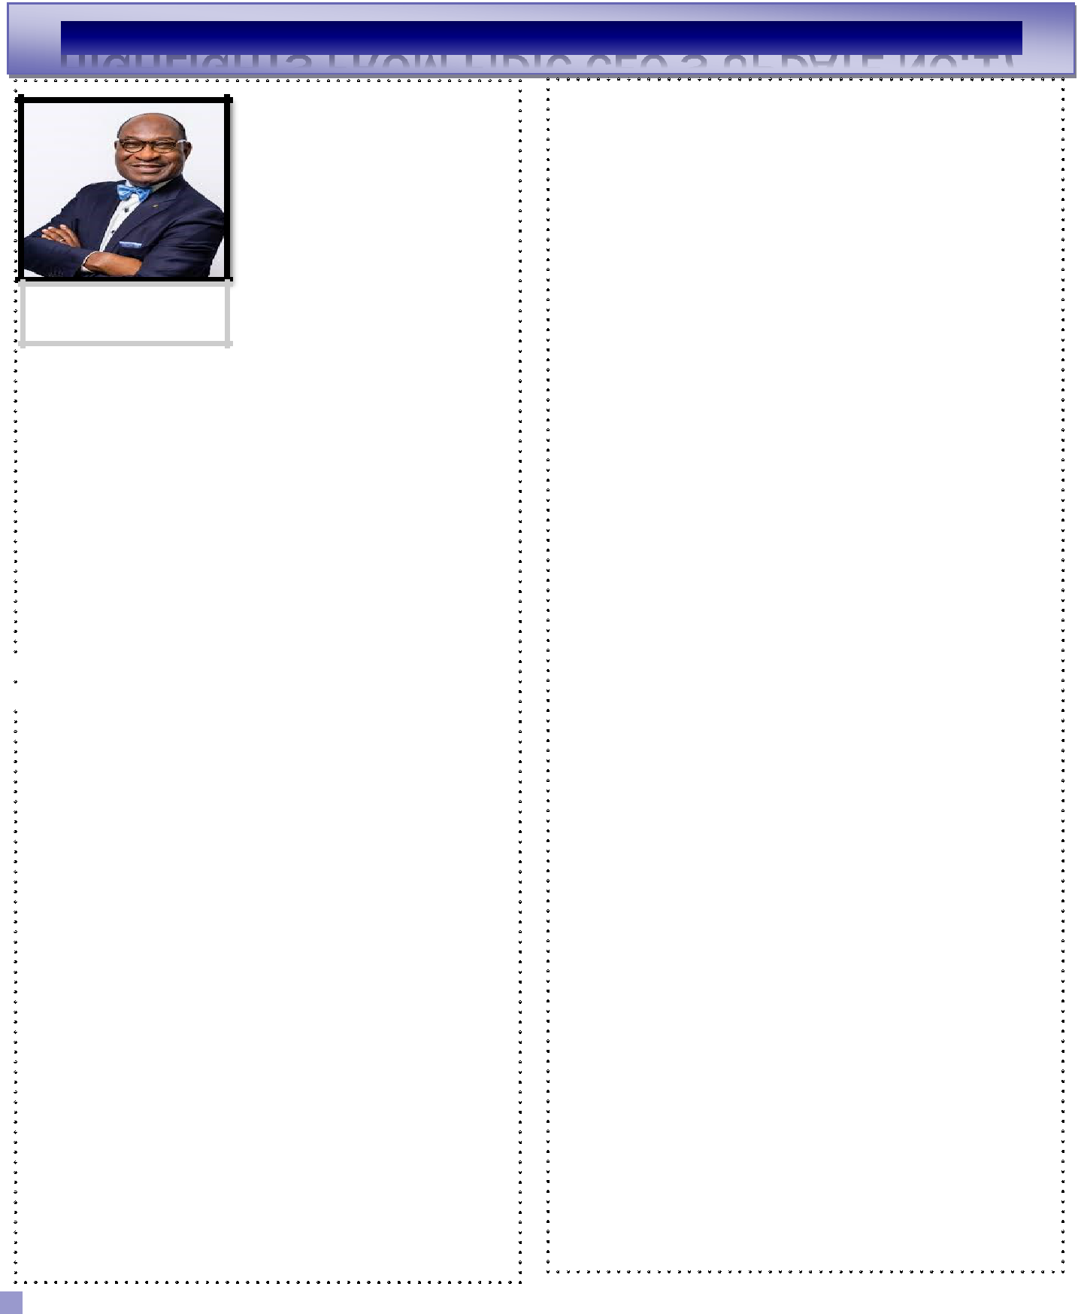

**FIDIC AFRICA 27th IN-**

**FRASTRUCTURE CONFER-**

**ENCE 2021**

It was a real pleasure to support the

newly rebranded FIDIC Africa re-

gion at their 27th Annual General

Assembly GAM and infrastructure

**Dr. Nelson Ogunshakin**

**OBE—***FIDIC CEO* programme delivered between 17- 19

May. The programme provided the

opportunity for the FIDIC president Bill Howard to address the GAM on FIDIC’s progress and strategic activities and I also con-tributed as one of the keynote speakers on the conference day one opening session on the role of consulting engineers in a changing

environment. The conference was well attended and congratula-tions to Engr Kabelo Motswagole FIDIC Africa president and

Chris Campbell, FIDIC Africa secretary for hosting a successful conference.

——————————————————————————-

 **ARRANGEMENTS FOR 2021 GAM WELL AD-**  **VANCED**

The board discussed the ongoing arrangements and roadmap for our FIDIC General Assembly Meeting (GAM) which takes place online on Tuesday 14 September. The GAM is a crucial event for FIDIC as it sets the organisation’s course for the future and ap-proves our annual report. The GAM also elects new members of the FIDIC board and for the vacancies we have this year, all nomi-nations are currently being reviewed for eligibility criteria and the candidates will be interviewed before being presented to the mem-bership for election. All member associations will receive full details of the GAM soon and I would encourage all to attend this important event in the FIDIC calendar.

———————————————————————–———

**FORMATION OF FIDIC NORTH AMERICA**

I was delighted to see the board ratify the formation of FIDIC North America under a memorandum of understanding (MOU) that has been signed by all the members of FIDIC in the region. This coming together of the American Council of Engineering

Page 6

Companies, Association of Consulting Engineer Companies Canada and the National Chamber of Consulting Companies Mexico under the banner of FIDIC North America is an historic step and one which will strengthen cooperation between all the engineering in-dustries throughout the region. The MOU brings together the repre-sentative organisations of consulting engineering companies across the United States, Mexico and Canada in a way that will enable them to represent the region’s business and professional interests with a greater focus than previously, all under the FIDIC banner. The formation of FIDIC North America is the latest step along the road in the implementation of FIDIC’s global regional strategy and is a welcome development for all our members in the region and for FIDIC. I would like to take this opportunity to thank the presidents of the three FIDIC member associations and also Linda Bauer Darr (ACECUSA), John Gamble (ACEC Canada) and Marco Gutierrez Huerta (CNEC Mexico) for their shared vision and leadership in making the formation of the new regional group a reality.

———————————————————————————-

**FIDIC ACADEMY UPDATE**

The board also received an update on the latest developments with the FIDIC Academy, the new brand under which we will bring all our training activities to enable us to better pro-mote the courses we offer and be more visible in the market-place. The board heard that good progress is being made with the implementation of a new learning management sys-tem (LMS) which will help FIDIC to improve the manage-ment, marketing, implementation and profitability of our training courses. Clients will also benefit from the new LMS platform, including improved accessibility to the training information and registration process, a quicker registration experience and better learner engagement. The new FIDIC Academy brand will enable us to raise our profile in the digi-tal training arena and provide FIDIC with the opportunity to develop a commercially viable partnership with member associations in the delivery of a future training and capacity building programme. We are currently onboarding existing training programmes and expect to fully launch the new

THE GCEA NEWS



FIDIC Academy during Q3 2021

——————————————————————————-

**FIDIC AMBASSADOR PROGRAMME**

Board members also signed off on the implementation plans for the setting up of the new FIDIC Ambassador programme, which is due to be launched in Q3 2021. The programme was originally approved by the board in Q1 2020, but we had to delay the imple-mentation until this year. The FIDIC Ambassador programme will expand FIDIC’s footprint across the globe and help us to achieve our objectives more efficiently. It will provide FIDIC members with a list of dedicated professionals working within the infra-structure industry that will advocate for FIDIC principles and objectives and facilitate the development of more high added val-ue services and answers to member needs. Ambassadors will be enthusiastic and creative professionals who will volunteer with their time to help promote the vision, mission, and objectives of FIDIC and, in consultation with the FIDIC president, board and CEO, they will seek to influence decision makers in governments, the engineering and construction industry, infrastructure asset owners, multilateral development banks and contracting authori-ties regarding popularising and adopting FIDIC best business practices. The FIDIC nominations committee is now organisation the implementation strategy for the new programme and full de-tails will be circulated soon to member associations inviting nomi-nations from past FIDIC volunteers that are eligible to become a FIDIC Ambassador

—————————————————————————–

**FIDIC EUROPE BOARD**

The board also agreed the terms of reference for the new FIDIC Europe board, which we anticipate will be set up before the end of Q2 2021 and which paves the way for the further implementation of FIDIC’s regional strategy. The composition of the FIDIC Eu-rope board will be made up of 6 candidates which will include two members from non-EU countries and four from EFCA member countries. The FIDIC Europe board will be chaired by EFCA president Benoit Clocheret and will see FIDIC working ever more closely with EFCA to be the voice of FIDIC in Europe. The board will have a key role to play in our engagement programme with the multilateral development banks and other key institutions based in Europe. The first meeting of the FIDIC Europe board is

Page 7

expected to take place before the end of Q2 2021. I would like to take this opportunity to thank Tony Barry, FIDIC president elect, Benoit Clocheret, EFCA president and Mark Pehlig, FIDIC board member, for their collective contributions towards achieving clo-sure on this task.

——————————————————————————

**NEW CONTRACT COMMITTEE MEMBERS**

The board also received news of the appointment of four new FIDIC contract committee members, which further strengthens this important committee which oversees the development of the FIDIC Suite of Contracts and related documents and advocates and guides best practice in FIDIC contracts across the global engineering and construction industry. The new appointments bring to five the num-ber of new candidates for the committee - Mahmoud Abu Hussein (Egypt), Adriana Spassova (Bulgaria), Jafar Khan (UAE), Keith Leung (Singapore) and Eoin Cullinane (Republic of Ireland). I look forward to all of them playing a key role on the committee.

———————————————————————————

**FIRST WOMAN CHAIR OF ACEC**

Many congratulations to Robin Greenleaf who has been elected as chair of the American Council of Engineering Companies (ACEC) for 2021-2022. Robin is the CEO of Architectural Engineers, Inc. (AEI), a women-owned mechanical, electrical, plumbing, fire pro-tection and lighting design services firm based in Boston, Massa-chusetts and is also the first woman to be chair of ACEC. This is a major milestone achievement for our industry and I could not think of a better candidate than Robin for this ground-breaking landmark for ACEC-USA. I look forward to working with Robin and my colleague Linda Bauer Darr and the rest of the ACEC team over the coming months as we progress with the implementation of the FIDIC North Americas region

———————————————————————————-

**FIDIC AWARDS**

A reminder that we will shortly be announcing the official call for entries for this year’s FIDIC awards – the Future Leaders, FIDIC Project Awards, Member Association Excellence Awards and the FIDIC Contracts Awards. These four awards programmes will be staged at different parts of the year between September and Decem-

THE GCEA NEWS



ber 2021. Do keep an eye on the FIDIC website for the official launch of the call for entries for all these awards.

——————————————————————————-

**WEBINAR SERIES UPDATE**

The latest event in FIDIC’s Covid-19 2021 webinar series took place on 11 May 2021 with an event looking at change and its effects on project delivery and the construction and infrastructure industry. The webinar, “Dealing with change in uncertain times”, was attended by 530 people and looked at some of the current events which have made change more likely and potentially more costly and highlighted how FIDIC contracts deal with change requests and the effects of unplanned and unscheduled changes. Our webinars continue to enable FIDIC to reach out to a wide range of stakeholders and we are increasing our profile in the in-dustry as a result. Click on the link below to find out more about the great events we have in store over the coming months.

——————————————————————————

**OFFICIAL CONTRACT USERS’ CONFERENCE— NORTH AMERICA, LATIN AMAERICA AND CAR-IBBEAN TIME ZONE**

The first **Official FIDIC Contract Users’ Conference** to be staged online and delivered in-house under new arrangements takes place from 25 to 28 May 2021. The event, targeting both the Latin America, North America and Caribbean contract users’ community will be delivered in English, Spanish and Portuguese and offers the opportunity to share progress on the application and use of the FIDIC suites of contracts in the region and will include participation from MDBs, private sector organisations and clients, government, engineers, contractors, investors and other stakehold-ers with an interest in FIDIC contracts.

**WINNER OF CROSSWORD PUZZLE No.1**

**MICHAEL ACHEAMPONG**

**CIVIL ENGINEER @ DAOVTECH DE-SIGN GROUP.**

Page 8

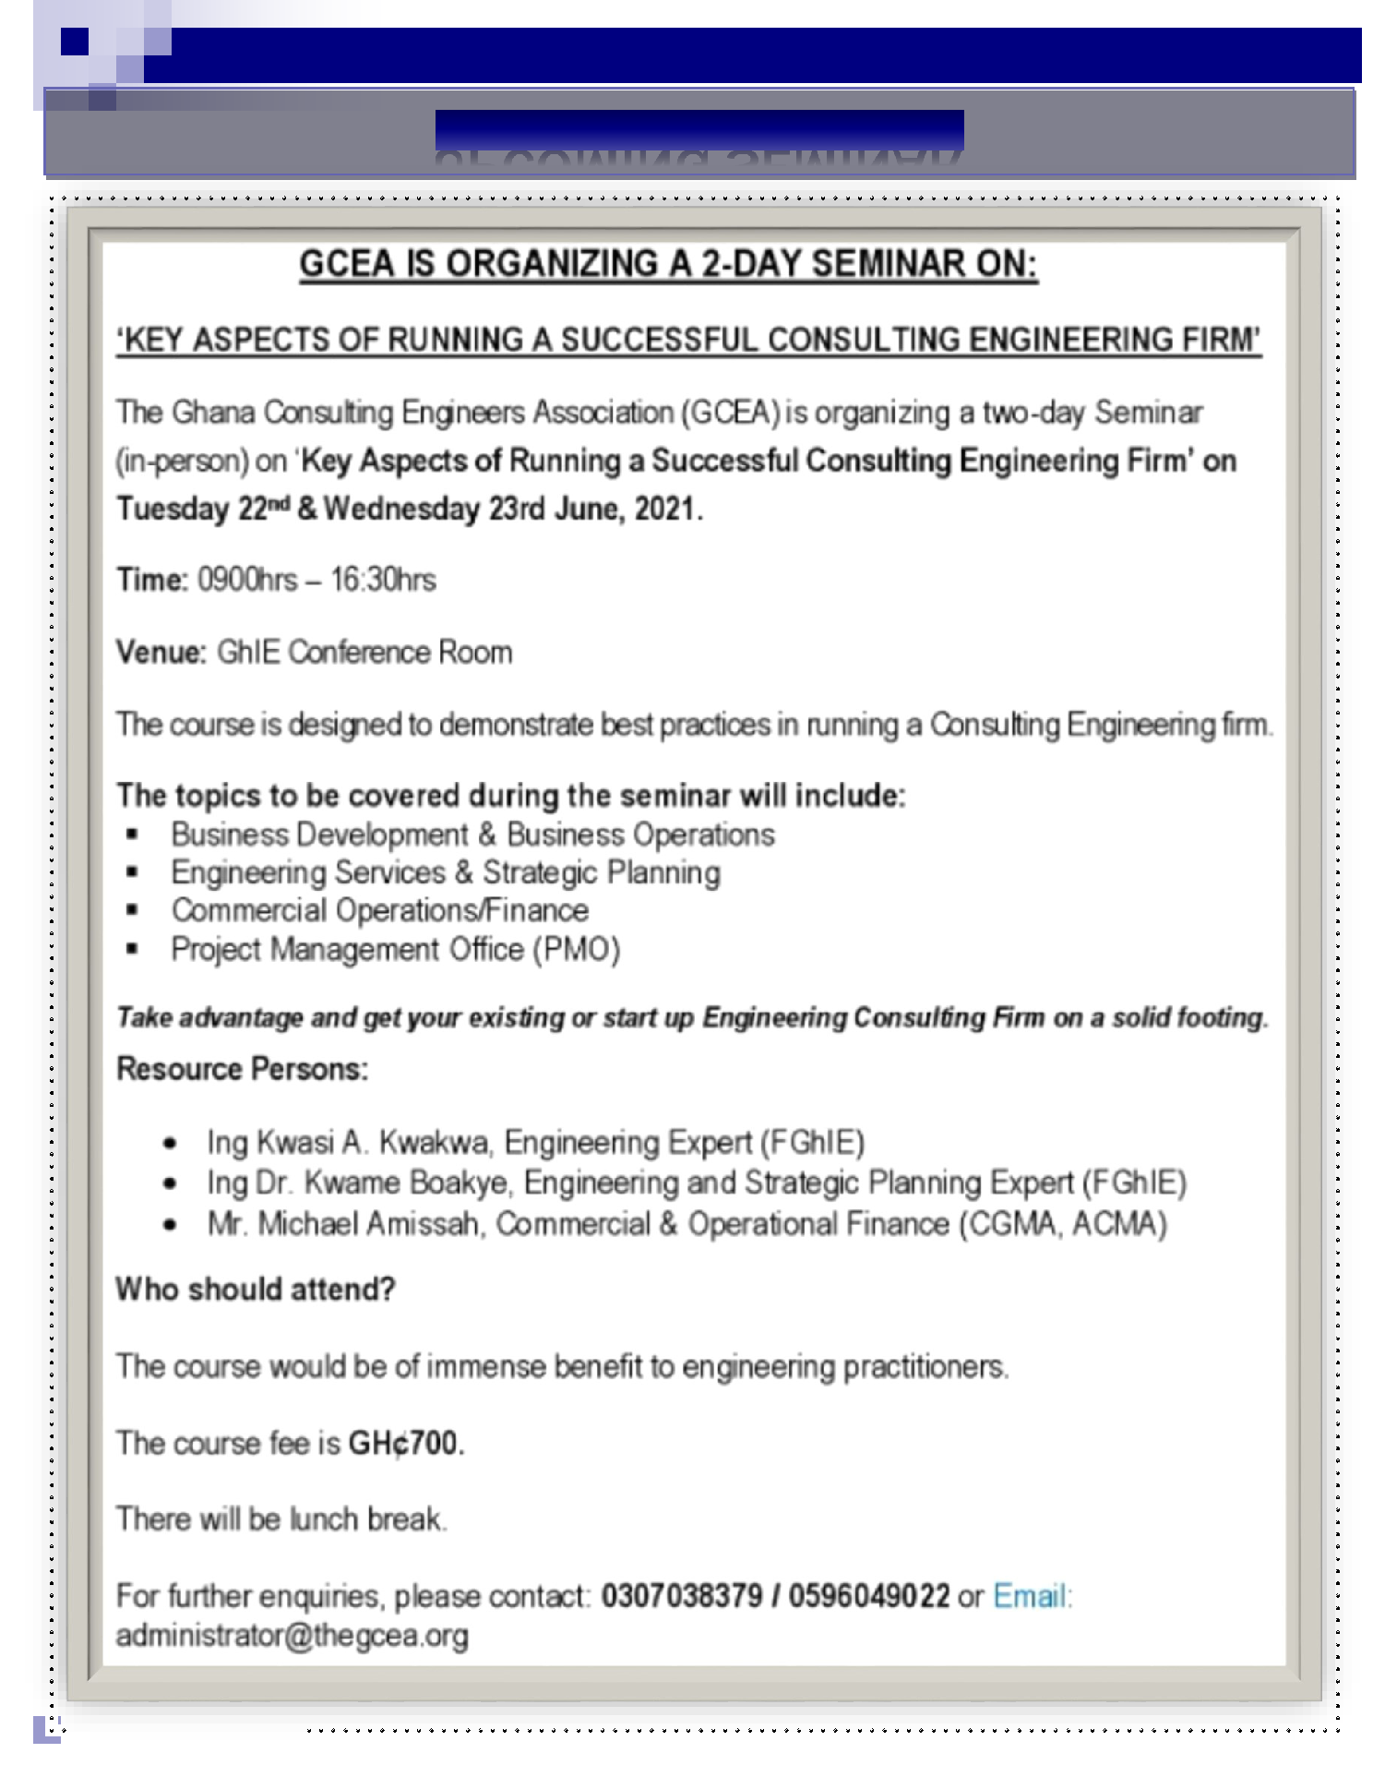THE GCEA NEWS

 Page 9 

THE GCEA NEWS

CROSSWORD PUZZLE No.2

STEPS:

1. SOLVE THE PUZZLE
2. SEND ANSWER(S) TO GCEASOCIALS@GMAIL.COM
3. WIN FANTASTIC PRIZES!!!!

**HINT: WATER**

Page 10

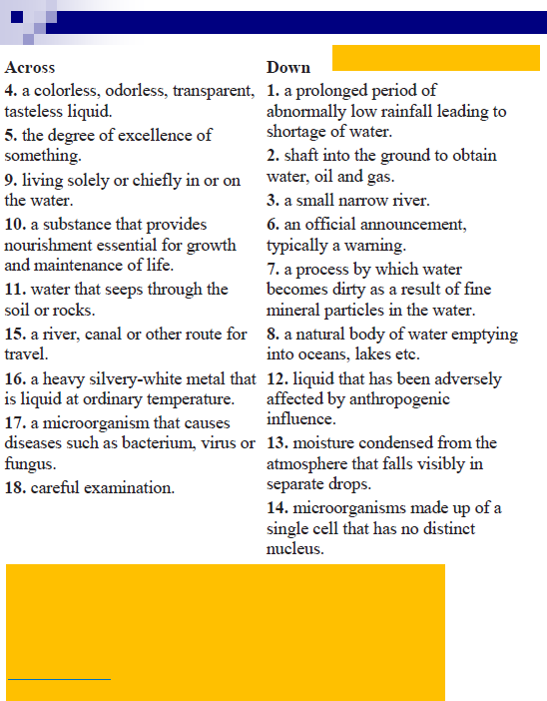THE GCEA NEWS

CROSSWORD PUZZLE No.2

STEPS:

1. SOLVE THE PUZZLE
2. SEND ANSWER(S) TO GCEASOCIALS@GMAIL.COM
3. WIN FANTASTIC PRIZES!!!!

**HINT: WATER**

Page 11

THE GCEA NEWS

NEW GCEA MEMBERS

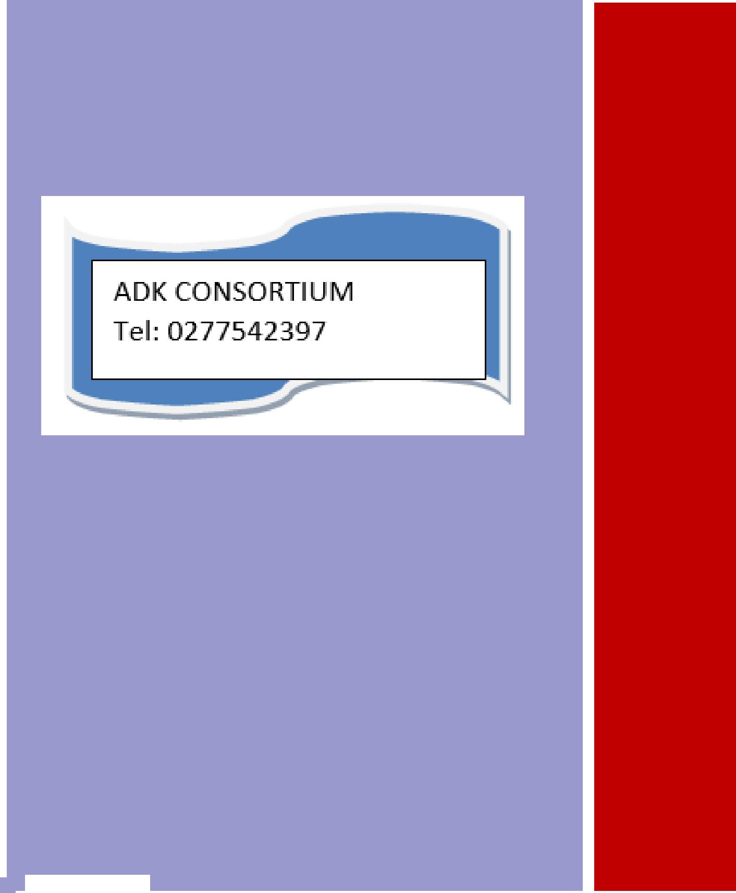

G

C

E

A

Page 12

THE GCEA NEWS

Page 13

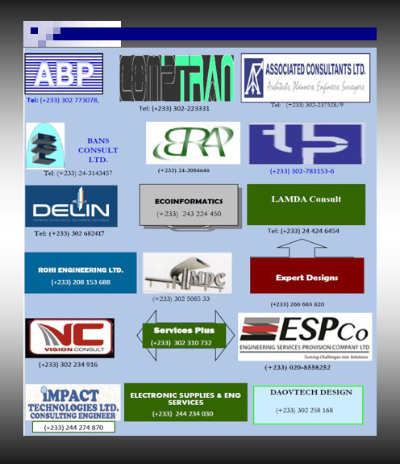GHANA CONSULTING ENGINEERS ASSOCIATION NEWSLETTER

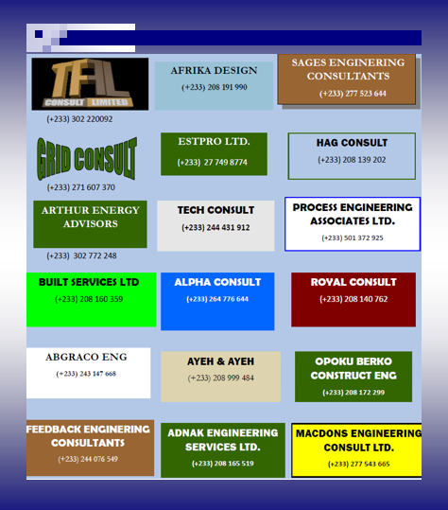GHANA CONSULTING ENGINEERS ASSOCIATION NEWSLETTER

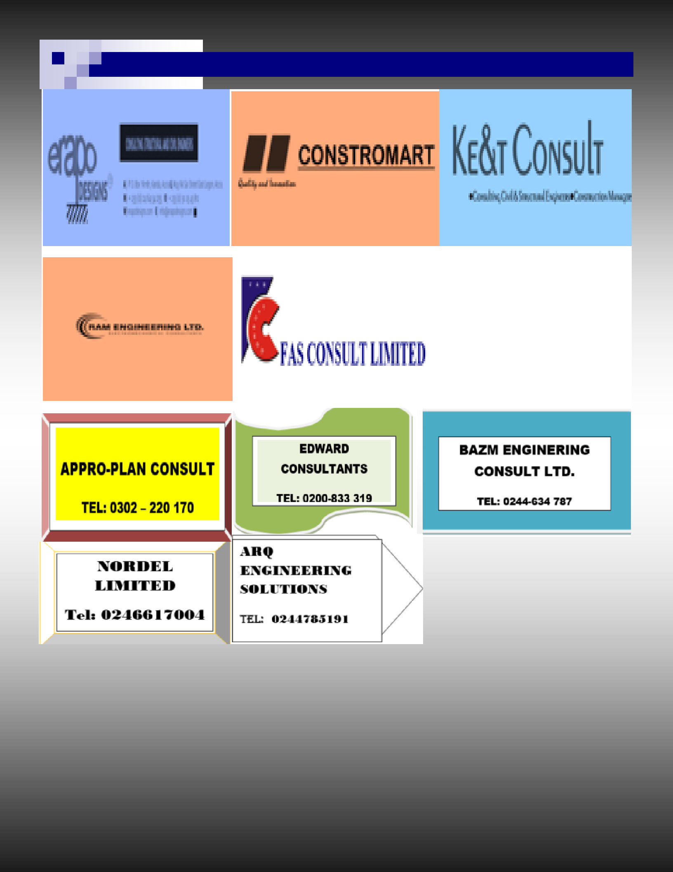GHANA CONSULTING ENGINEERS ASSOCIATION NEWSLETTER

GHANA CONSULTING ENGINEERS ASSOCIATION NEWSLETTER

***Engineers Centre, 13 Continental Road,***

***Roman Ridge, Accra, Ghana***

***P. O. Box OS 1768, Osu – Ghana***

*Membership is open to all Consult-ing Firms in the country. Staff of Member Firms who want to join any of the committees can send a mail or call the numbers below.*

We’re on the web

@ gcea.org.gh

CONTACT DETAILS:

Phone: +233-30-7038379 / +233-501565832

Email: gceagh@gmail.com & [admin@gcea.org.gh](mailto:admin@gcea.org.gh)

*MFs are being encouraged to set-up SOCIAL MEDIA accounts to help publi-cize the Association and the Ghanaian Engineering Community at large.*